1. Create Repo in the Github
Open: https://github.com/new
- Repo name: my-scripts
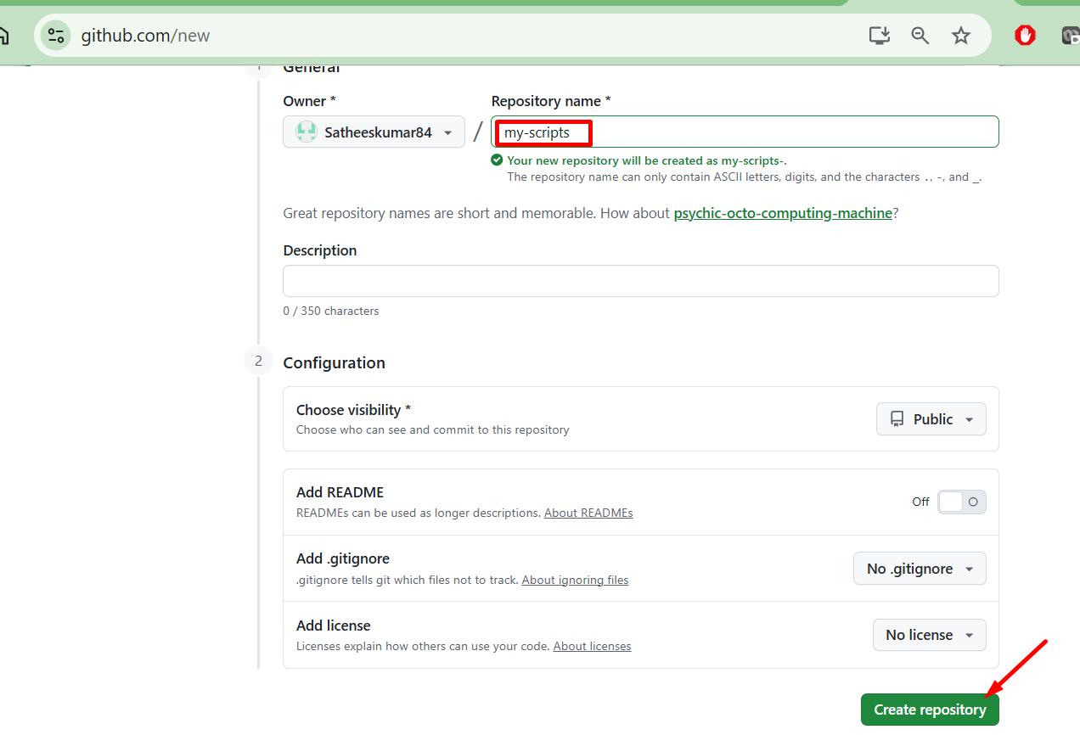

2. Create Directory in the EC2 instance and the script files
mkdir my-scripts
cd my-scripts

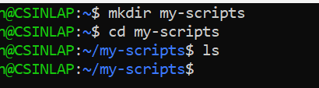
Create simple scripts:
echo "Write-Host 'Hello from PowerShell'" > script.ps1

echo "# My Personal Scripts" > README.md

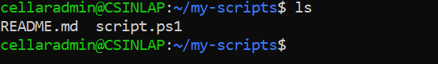

3. Initialize Git & First Commit
git init
git add .
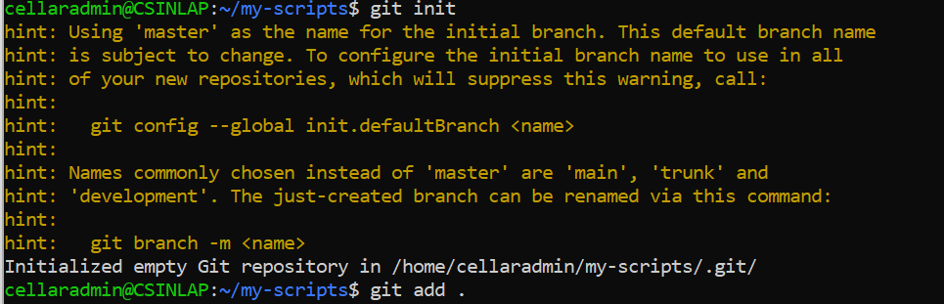

git commit -m "Initial commit"

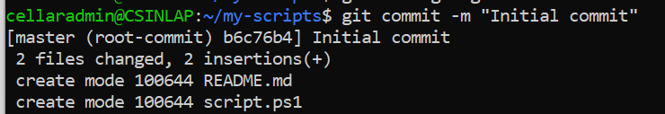

4. Connect to Your GitHub
git remote add origin https://github.com/Satheeskumar84/my-scripts.git

git branch -M main
git push -u origin main
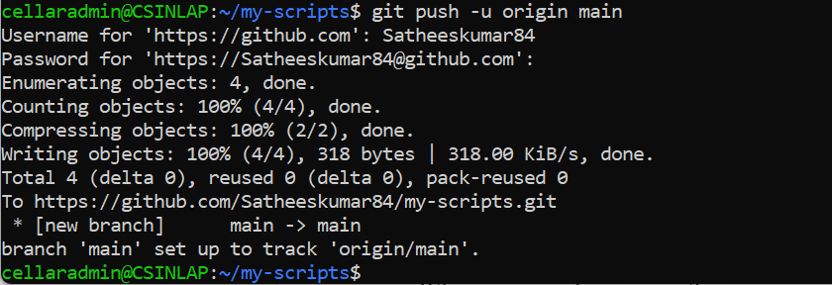
Now the scripts have been pushed to GitHub

5. To verify

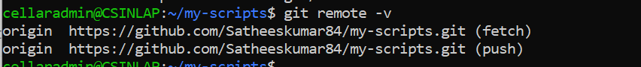

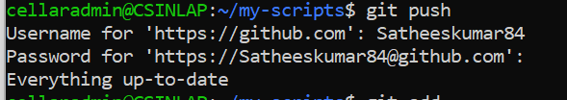

6. MERGE
Create a branch:
git checkout -b test-change
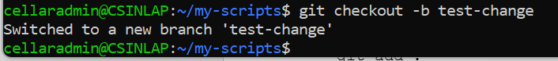
Edit file:
echo "Test change" >> script.ps1
git add .
git commit -m "Test update"
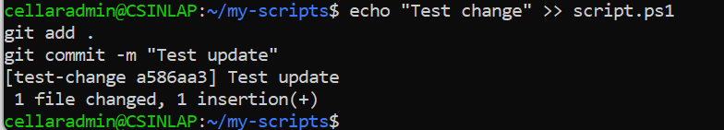
Merge back:
git checkout main
git merge test-change
git push

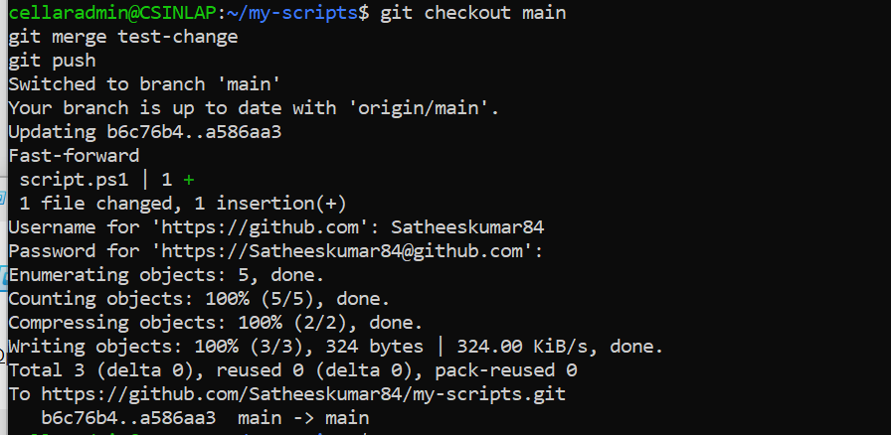

7. REBASE
Instead of merge:
git checkout test-change
git rebase main

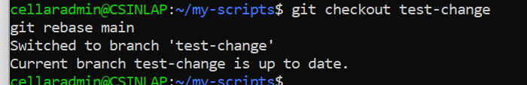
Then:
git checkout main
git merge test-change

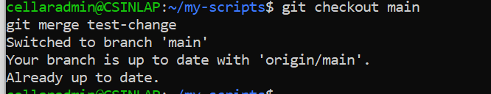

8. STASH
When you don’t want to commit yet:
echo "Temp work" >> script.ps1
git stash
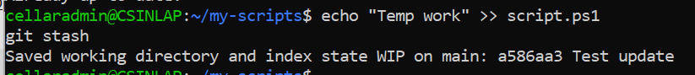
Later:
git stash pop
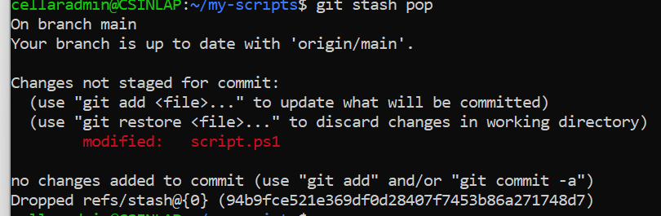

We can see the script filers in the GitHub repository
